**Chapter 5 input device and sensor**

You need to describe/select suitable input devices in relation to the requirements of the application.

1. **Scanner**

* Two-dimensional scanners

These scanners are used to input hard-copy(paper) documents, then converted it into an electronic form which can be stored in a computer.

* 3D scanners

3D scanners scan solid objects and produce a three-dimensional image.

**Application of 3D scanning**

|  |  |  |
| --- | --- | --- |
| **X-rays** | **CT scanners** | **Computerised tomography** |
| **Radio frequencies** | **MRI** | **Magnetic resonance imaging** |
| **Gamma** | **SPECT** | **Single photon emission computed tomography** |

1. **Barcode readers**

A barcode is a series of dark and light parallel lines of varying thickness. The number 0 to 9 are represented by a unique series of lines.

**The application of barcode—Supermarket**

|  |  |
| --- | --- |
| **Input/output device** | **How it is used** |
| Keypad | To key in the number of same items bought; to key in a weight; to key in the number under the barcode if it cannot be read by the barcode reader |
| Screen/monitor | To show the cost of an item and other information |
| Speaker | To make a beeping sound every time a barcode is read correctly |
| Printer | To print out a receipt/itemised list |
| Magnetic stripe reader | To read the customer’s credit /debit card |
| Touchscreen | To select items by touching an icon |

**Advantages of using barcodes to the management**

* Much easier and faster to change prices on stock items
* Much better, more up-to-date sales information
* No need to price every stock item on the shelves
* Allows for automatic stock control
* Possible to check customer buying habits more easily by linking barcodes to, for example, customer loyalty cards

**Advantage of using barcodes to the customers**

* Faster checkout queues
* Errors in charging customers are reduced
* The customer is given an itemised bill
* Cost savings can be passed on to the customer
* Better track of ‘sell by dates’ so food should be fresher

1. **Quick response(QR) codes**

* QR code is another type of barcode. Normal barcodes can hold up to 30 digits. QR codes can hold over 7000 digits.

**Advantage of QR code**

* There is no need for the user to write down or key in a website address; scanning the QR code does this automatically
* QR codes can store website address that appear in magazines, trains, buses or even on business cards, giving a very effective method of advertising.

1. **Digital camera**

The photo is captured when light passes through the lens onto a light sensitive cell.

1. **Keyboard**

Each character pressed is converted into a digital signal, which the computer interprets.

* The problem:

Frequent use of these devices can lead to injuries, such as Repetitive Strain Injury(RSI) in the hands and wrists.

* Solve the problem:

Ergonomic keyboard can help to overcome this problem, they are designed to give more support to the wrists and hands when doing typing.

1. **Pointing devices**

**i The forms of mouse:**

* Mechanical ball mouse: connected to the computer through a USB port
* Optical mouse: Use red LEDs to detect movement in the X-Y direction
* Wireless mouse: use a wireless connection to the computer

**ii Trackerball**

* Often use in an industrial environment, the trackerball does not need any desk space or special surface.

**iii Touch pad**

* This contains a tactile 触觉 sensor which allows the user to control a cursor by moving a finger over the surface of the pad.

1. **Microphone**

Microphone are used to input sound to a computer.

1. **Touchscreens**

Three types of touchscreen technologies to mobile phone screens:

**i Capacitive 电容**

This is made up of many layers of glass that act like a capacitor, creating electric fields between the glass plates in layers

* **Benefit**

This is medium cost

Screen visibility is good even in strong light

It permit multi-touch capability

The screen is very durable, it takes a major impact to break the glass

* **Drawbacks**

Allows only the use of bare fingers as the form of input

**ii Resistive 电阻**

This makes use of an upper layer of polyester and a bottom layer of glass.

* **Benefits**

It is inexpensive technology

It is possible to use bare fingers, gloved fingers or a stylus to carry out an input operation.

* **Drawbacks**

Screen visibility is poor in strong light

It does not permit multi-touch capability

The screen durability is only fair, it is easy to scratches.

**iii Infra-red 红外线**

* **Benefits**

Both systems allow multi-touch capabilities

The optical system allows the use of bare fingers, gloved fingers or a stylus for input

Both systems have good screen durability

* **Drawbacks**

It is expensive technology

Heat-sensitive system only allow bare fingers to be used for input

Both systems have fairly good screen visibility in strong sunlight

1. **Interactive whiteboards**

They are devices that allow computer images to be displayed on a whiteboard using a digital projector.

1. **Automatic data capture**
2. Optical character recognition（OCR ） （光学字符阅读器）

Computer equipped with optical character recognition(OCR) software allow the scanned text from the document to be converted into a TEXT file format.

2.Optical mark reader（OMR ） （光标阅读机）

3.Magnetic ink character recognition（MICR） （磁墨水字符识别）

4.Radio-frequency identification(RFID) tag reader （射频识别目标阅读器）

5Magnetic stripe reader（磁条阅读机）

6.Smart card reader（智能卡读卡器）

7.Biometric data capture devices（生物识别数据捕捉设备）

**2. Sensor**

**You should be aware of the different types of sensor used in a wide variety of control and monitoring applications**

* Temperature(温度) sensor
* Humidity\moisture(湿度) sensor
* Light(灯光) sensor
* Pressure(压力) sensors
* Infrared(红外线) sensor
* Microwave (微波) sensor
* Gas(气体) sensor

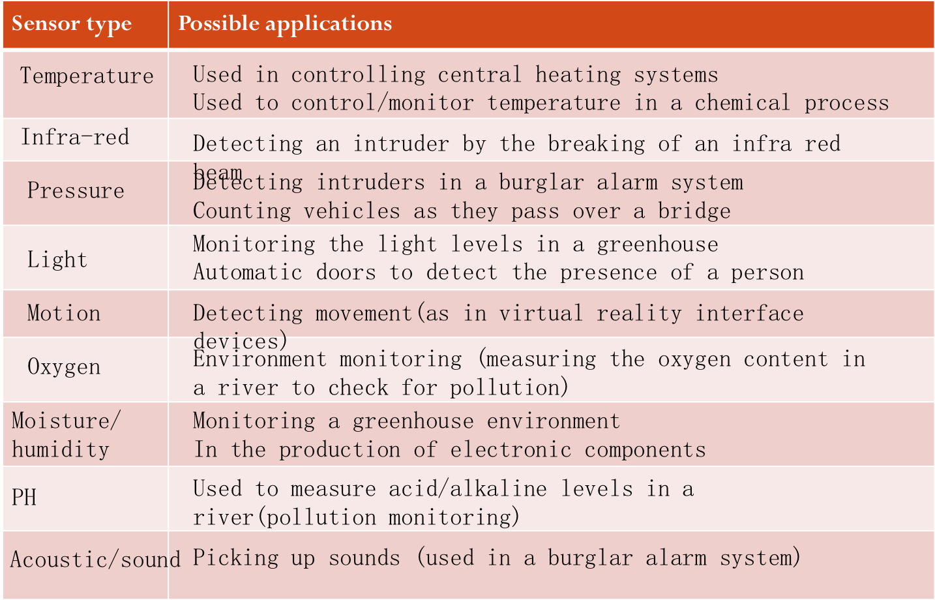

**3. Monitoring and control**

**(1) EXAMPLE—— monitoring(a burglar alarm system)**

* Gather data from sensors(pressure, infra-red, motion) in the house
* Signal are sent to an ADC where they are converted into digital
* The digital information is then sent to the computer
* The computer compares this information with pre-set data
* If it is out of range (example, pressure too high, beam has been broken, etc) then a signal is sent to sound an alarm
* Alarm continues to sound until system is re-set
* System continues to monitor sensors until turned off

**(2) EXAMPLE—— control (a chemical process)**

* Gather data from sensors(temperature, pressure) from the reactor vessel
* Signals are sent to an ADC where they are converted into digital
* The digital information is then sent to the computer
* The computer compares this information with pre-set data
* if temperature<80o a signal is sent to an actuator to switch on the heater
* If pressure < 2 bar a signal is sent to an actuator to open the valve.
* DAC is used to convert signals to analogue to control heater and valves.
* This continues until the chemical process is completed.

**(3) Why is this done?**

* it is safer (even though humans can work in shifts there is always the danger of missing information at shift handover etc.)
* Computers can run 24 hours a day, 365 days a year. (faster response to non-standard conditions and they don’t get tired)
* computers are more accurate and can take more frequent readings (e.g. if readings need to be taken every 30 seconds, humans can make mistakes or miss readings or even find it is impossible to take readings at a short time intervals)
* data can be automatically displayed and analysed without the need to enter data manually (which in itself could introduce errors into the system)